Technical Building Block
RPi PICO Programming using Python
ID:TBB0009.
- Purpose:
To Flashing a Custom Firmware to Rpi Pico with Thonny IDE.
- Part Number, datasheet and pinout:
Part #: Rpi pico board.
Datasheet : https://robu.in/product/raspberry-pi-pico-with-headers/?gclid=EAIaIQobChMIkoXt4Ojr-QIVTqaWCh2H4gOdEAQYBCABEgI7E_D_BwE
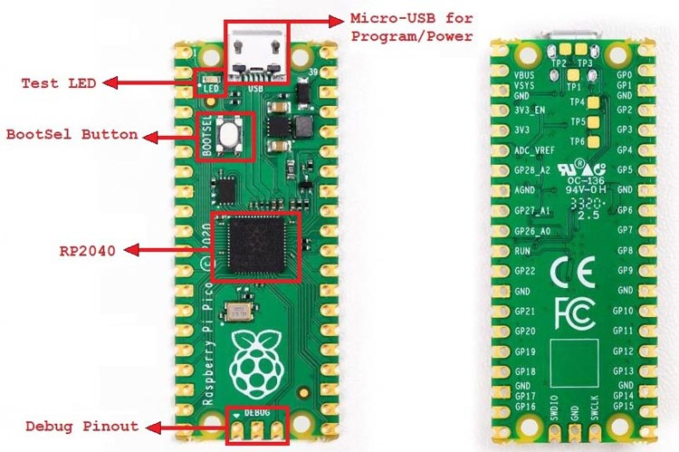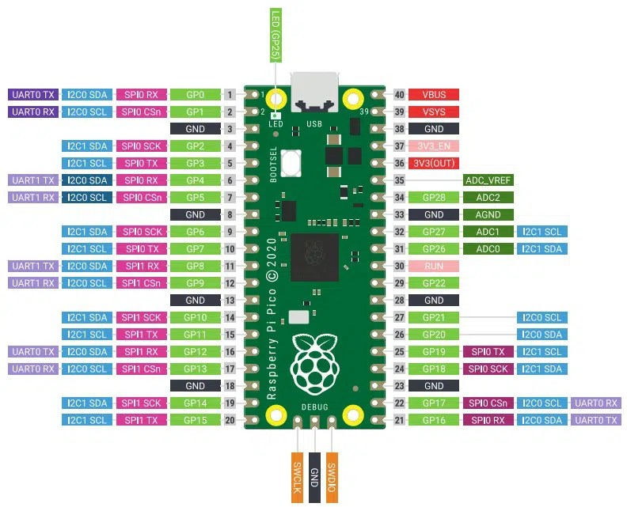

- Prerequisites Raspberry Pi Pico GPIO Programming:
In order to start, make sure you have performed the following procedures already:
- Downloaded and installed the latest version of Python 3 on your PC.
- Downloaded and installed the latest version of Thonny IDE.
- Set up MicroPython in Raspberry Pi Pico.

If you want to know how to perform above steps, you can follow this step by step guide:
Getting Started with Raspberry Pi Pico using Thonny IDE

- Procedure for programming: once installing all software. Click in the main editor pane of Thonny. Enter the code and save it in rpi Pico. Thonny can save and run MicroPython programs directly on your Raspberry Pi Pico.

Ref link: https://projects.raspberrypi.org/en/projects/getting-started-with-the-pico/5

